
Program on Disabilities
Hillside Elementary School
Needham, MA, USA

2nd Grade Workshop
on
HEARING LOSS
and
DEAF & HARD OF HEARING PEOPLE

Curriculum Developed by

Kim Marie Nicols, MSW, MA
12 Crescent Road
Needham, MA 02494 USA
781-455-8178
Kim_Marie_Nicols@yahoo.com

©2013

(Materials may be used in disability awareness programs with credit given to
Kim Marie Nicols, MSW, MA and Hillside Elementary School, Needham, MA, USA)
Hillside Elementary School Program on Disabilities – Hearing Loss
Kim Marie Nicols, MSW, MA

The Program on Disabilities for 2nd graders in Needham Public Schools focuses on Hearing Loss. Using parent volunteers, this workshop introduces students to American Sign Language, lipreading, a simulated hearing loss, and facts about Deaf and Hard of Hearing people. In addition, they may handle hearing aids, see the structure of the ear and ear bones, and look at sign language books.

The Program on Disabilities was developed by the Hillside Elementary School Parent Teacher Council (PTC) over a dozen years ago to introduce students to various disabilities in order to increase awareness and understanding of people who may be different from themselves. It is an extremely successful annual program, and has now expanded to all five elementary schools within the Needham Public School system in Needham, Massachusetts, USA. Students participate in grade-specific workshops that focus on different disabilities:
First Grade – Vision Loss
Second Grade – Hearing Loss
Third Grade – Mobility Issues
Fourth Grade – Developmental and Learning Disabilities
Fifth Grade – Emotional Disabilities
In addition to the grade-specific workshops, guest speakers are invited to teach students about what it is like to live with their peculiar disability. Special school-wide assemblies, with a presentation by a motivational speaker who is disabled or a performance group with disabled members, are also offered.

Hillside Elementary School Program on Disabilities – Hearing Loss
Kim Marie Nicols, MSW, MA

The workshop requires about an hour for each 2nd grade classroom. The students should be divided into four groups (with 4 to 6 children in each group) and they will rotate between four stations every 10 minutes.

At least five parent volunteers are needed for each classroom. If possible, all the parents should be trained on the materials ahead of time, although three of the stations can be presented with minimal preparation.
1. American Sign Language station
2. “Unfair Hearing Game” station
3. Lipreading station
4. Deaf Awareness and Hearing Aids station
5. Introduction and Conclusion, as well as Timekeeper

Every student needs a Pencil and a Copy of:
1. “American Sign Language Alphabet” (page 12)
- “American Sign Language Numbers from 1 – 10” (page 13)
- “An Unfair Hearing Game” - minus the answers (pages 16 & 17)
- “Ask Me About…” (page 30)

Equipment needed includes:
- Internet connection and speaker for the “Unfair Hearing Game”
- Large Index Cards of each one of the Lipreading Words or Phrases
(see the list on “Lipreading Exercises”)
- Pictures and/or model of the Ear Organ and Bones
- Pictures and/or actual Hearing Aids and Molds
- Sign Language Books
Hillside Elementary School Program on Disabilities – Hearing Loss
Kim Marie Nicols, MSW, MA

Introduction (10 Minutes)

All the students gathered together in one group.

If one of the parent volunteers is fluent in American Sign Language, it is very effective to have her interpret the introduction. The students immediately realize that they will be experiencing something very different for the next hour. The parent doing the introduction can explain that the Interpreter is translating English into American Sign Language used by Deaf people.

The introduction should include:
- Explanation about the Program on Disabilities, and how they learned about visual problems in 1st grade, and as 2nd graders they will learn about hearing loss.
Use correct terminology – calling people who have a hearing loss “Deaf” or “Hard of Hearing”, and not using archaic words like “Hearing Impaired” or “Deaf and Dumb” or “Deaf Mute”.
- Introduce the Parent Volunteers.
- Short discussion about the children’s personal experiences with a family member or friend who is Deaf or Hard of Hearing.
- Explanation of how we hear, showing the ear organ and ear bones.
(see instructions)
- Brief overview of what the students will learn about hearing loss in each of the four stations, which will rotate every 10 minutes.
- Distributing the handouts and ensuring they each have a pencil.

It is the responsibility of this volunteer to also be the Timekeeper. The students will be at each station for approximately 10 minutes, so she needs to warn the other parents when they only have a minute left, and encourage the students to quickly go to the next station.

After the fourth rotation, she needs to have the students gather into one group again for the Conclusion.
Hillside Elementary School Program on Disabilities – Hearing Loss
Kim Marie Nicols, MSW, MA

The Ear & How We Hear (2 minutes, during the introduction)

Resources:
1. “Mechanics of the Ear”
2. “The Ear Organ”
3. “How the Ear Works”

Materials Needed:
- Pictures and/or model of the Ear Bones
- Pictures and/or model of the Ear Organ

Procedures:
- Pass around the Ear Bones picture/model
  - They are the smallest bones in the body, and fully formed at 2 months of age.
- Using the picture/model of the Ear Organ, explain how we hear sounds.
  - Sound arrives at the outer ear.
  - It hits the ear drum, causing vibrations.
  - The vibrations make the ear bones move, and they make the vibrations stronger.
  - The vibrations travel to the cochlear, where the 20,000 microscopic hair cells create nerve signals that go to the brain.
  - The brain lets us understand what we heard.
  - All this happens so quickly it is almost instantaneous.

Hillside Elementary School Program on Disabilities – Hearing Loss
Kim Marie Nicols, MSW, MA

Mechanics of the Ear
Parent Volunteer Instructions

Look at the model of the ear.

Using the fact sheet “How the Ear Works”, explain how sound enters the ear and is processed and interpreted by the brain.

Points to emphasize –
The ear bones are the smallest in the body and fully formed by
2 months of age.
There are 20,000 microscopic hairs in the cochlear.
It is almost instantaneous from when a sound is made to how the
brain identifies and interprets it.

THE EAR ORGAN

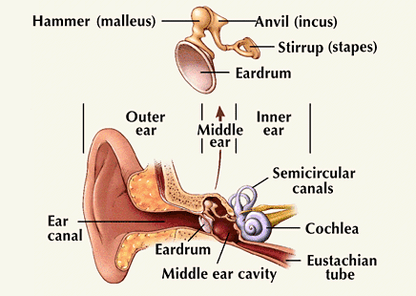

www.hearingaidscentral.com/howtheearworks.asp

THE EAR BONES

(Ossicles)

Life Sized Images

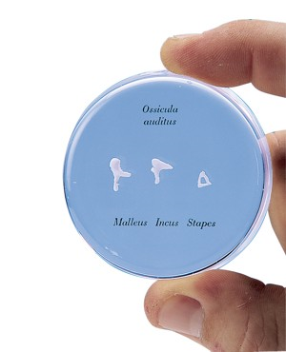
www.survivaltechnology.com

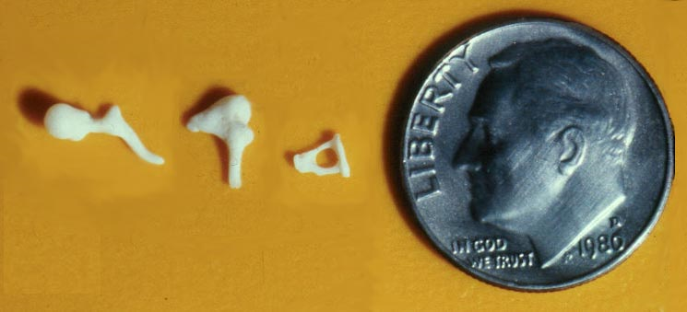
www.ear-anatomy.com

Hillside Elementary School Program on Disabilities – Hearing Loss
Kim Marie Nicols, MSW, MA

How the Ear Works

There are 3 parts of the ear -
Outer
Middle
Inner

The outer ear is the part that can be seen – the auricle (“or-ih-kul”) and the ear canal. The shape of the auricle helps it catches sound waves, which go into the ear canal.

In the middle ear, there is an eardrum and the ossicles (“ah-sih-kulz“) which are three tiny bones –
malleus (“mah-lee-us”) or hammer,
incus (“in-kus”) or anvil, and
stapes (“stay-peez”) or stirrup
The eardrum is a thin piece of skin stretch tight like a drum. When sound waves reach the eardrum it causes a vibration that moves the bones. The ossicles bones are the smallest in the human body – together they are tinier than the pinky fingernail.

The eustachian (“you-stay-she-un“) tube connects from the middle ear to the back of the nose. It makes sure that air pressure is the same on both sides of the eardrum. When ears ‘pop’ at high altitudes, it means that the pressure valve opened.

The vibrations from the middle ear go into the inner ear and enter the cochlea
(“ko-klee-uh“), which is like a curled up tube. It is filled with water and about 20,000 hairs that are so small they can only be seen through a microscope. The vibrations make the hairs move, creating signals that then go along the ear nerve to the brain. If the hairs are damaged and cannot move, then no signal goes to the brain, and that person has a hearing loss.

Also in the inner ear are 3 small loops called the semicircular canals which help with keeping balance.
Hillside Elementary School Program on Disabilities – Hearing Loss
Kim Marie Nicols, MSW, MA

American Sign Language (ASL) (10 minutes per each student group)
Station 1

This station requires more preparation by the parent volunteer than any of the other stations. Ideally, the parent knows the manual alphabet and some sign language already. Otherwise, she should become familiar with how to do the alphabet and numbers and learn some signs on the internet or through books (see the list of resources).

Materials Needed:
- “American Sign Language Alphabet” handout
- “American Sign Language Numbers from 1 – 10” handout
- Books on American Sign Language vocabulary (see the list of resources).

Manual Alphabet
- Model each letter of the alphabet, with all the students following along
  - Use only the right hand
  - Correct hand positions and hand shapes
- Fingerspell each student’s name individually with them

Numbers
1. Before they look at the handout, ask them to count on their fingers 1, 2, and 3
Teasingly correct them if they are counting 1, 2, and 6
2. Model each number, with all the students following along

American Sign Language
- Teach ASL words, such as those listed on the parent volunteer instruction sheet.
- Ask the students what words they want to learn, referring to ASL vocabulary books as needed,

Hillside Elementary School Program on Disabilities – Hearing Loss
Kim Marie Nicols, MSW, MA

American Sign Language
Parent Volunteer Instructions

Prepare ahead by learning the manual alphabet, numbers, and some sign language vocabulary.
Use internet resources that show you the correct hand shapes
and movements.

Teach each student group the alphabet, then assist them to individually fingerspell their name.

Teach the students how to count, emphasizing how to do number 3, and the progression of 6, 7, 8, and 9.

Teach some ASL signs, either deciding ahead of time what words, or with the students, look at the vocabulary book for words they want to learn.

Some favorite words for 2nd Graders are:
  - “Dog” – snapping fingers of right hand, which is D-O-G fingerspelled very fast
  - “Cat” – with both right and left hands forming “F”s, draw whiskers on face
  - “Pizza” – drawing “Z” with both index and middle finger of right hand
  - “School” – clapping hands twice
  - “Student” – signs for “book”, “learn” and “throw away” all together
  - “I love you” – I-L-Y handshapes all together
American Sign Language
Alphabet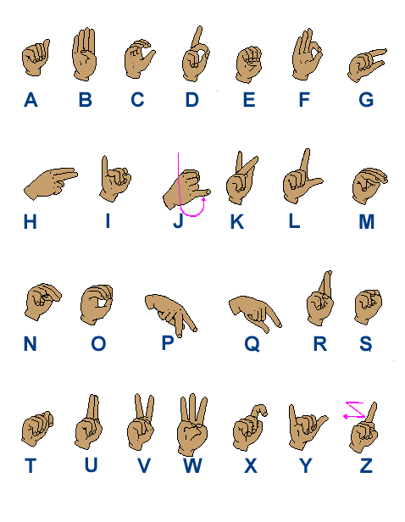

www.iidc.indiana.edu/cedir/kidsweb/amachart.html
American Sign Language
Numbers from 1 – 10
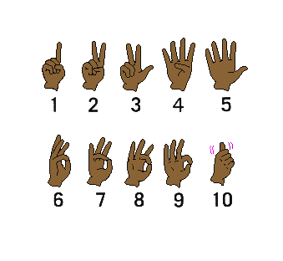

www.iidc.indiana.edu/cedir/kidsweb/amachart.html
Hillside Elementary School Program on Disabilities – Hearing Loss
Kim Marie Nicols, MSW, MA

Unfair Hearing Game (10 minutes per each student group)
Station 2

Materials Needed:
- “Unfair Hearing Game – Word Choices” handout
- “Unfair Hearing Game” answer sheet
- Pencil
- “Unfair Hearing Test” internet connection and speaker
www.irrd.ca/education/hear/hear2_1.wav

Procedures:
- Review all the words and pictures, since not all 2nd Graders read at the same level. It is okay if their copy is not in color, except one of the words is “Red”.
- Explain that they will hear words that simulate a moderate to severe hearing loss, and they should circle the word they think they hear. Warn them that they will get many or most of the words wrong, but it is just a game.
- Introduce the Unfair Hearing Game:
“You are going to play the Unfair Hearing Game. You will hear 10 words like a Hard of Hearing Person hears them. Sometimes you may not be sure if you heard a word right, so you have to make a guess. But that is okay. No one has EVER gotten them all correct. Ready…”
- Listen to the “Unfair Hearing Test” twice.
- Correct the words together.
- Laugh at the mistakes.
- Have a discussion about how many words sound similar and misunderstandings are common if you cannot hear clearly. The students or parent volunteer may have stories to share when this happened in their own lives.
Old joke: Three Hard of Hearing men were standing on a street corner. The first man says, “Brrr, it’s windy! The second one says, “No, it’s Thursday.” The third one says, “Me too, let’s go get a Coke.”

Hillside Elementary School Program on Disabilities – Hearing Loss
Kim Marie Nicols, MSW, MA

Unfair Hearing Game
Parent Volunteer Instructions

Pass out “Unfair Hearing Game – Word Choices”.

Review all the words and pictures.

Explain that they will hear words like a Hard of Hearing person does.

They should circle the words they think they hear.

Warn them that they will get many or most of the words wrong, and that is okay, since no one has ever gotten them all correct.
“You are going to play the Unfair Hearing Game. You will hear 10 words like a Hard of Hearing Person hears them. Sometimes you may not be sure if you heard a word right, so you have to make a guess. But that is okay. No one has EVER gotten them all correct. Ready…”

Listen to the “Unfair Hearing Test” at
www.irrd.ca/education/hear/hear2_1.wav

Correct the words together and laugh at the mistakes.

Discussion of how many words sound similar.

Hillside Elementary School Program on Disabilities – Hearing Loss
Kim Marie Nicols, MSW, MA

UNFAIR HEARING GAME
Word Choices

Page 1

1.



BILL FIN FILL





2.
CAT CATCH CAP

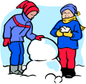



3.
FUN THUMB DRUM

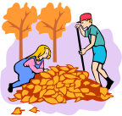
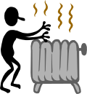


4.
HEAP HEAT PEEP





5.
WIDE CRIES WISE
Hillside Elementary School Program on Disabilities – Hearing Loss
Kim Marie Nicols, MSW, MA

UNFAIR HEARING GAME
Word Choices

Page 2



*

R
R
6.

WEDGE WED RED


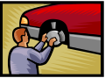

7.
FIX FISH FISTS

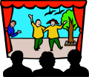

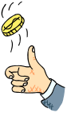
8.
SHOWS CHOSE SEWS

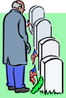
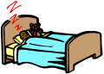


9.
DEAD BUG BED


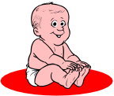


10.
PEACH JUICE CUTE
Hillside Elementary School Program on Disabilities – Hearing Loss
Kim Marie Nicols, MSW, MA

UNFAIR HEARING GAME
Answers

- FILL

- CATCH

- THUMB

- HEAP

- WISE

- WEDGE

- FISH

- SHOWS

- BED

- JUICE

Hillside Elementary School Program on Disabilities – Hearing Loss
Kim Marie Nicols, MSW, MA

Lipreading (10 minutes per each student group)
Station 3

Materials Needed:
- Create Large Index Cards of each one of the Lipreading Words or Phrases
(see the list on “Lipreading Exercises”)

Procedures:
- Seat the students in a circle or semi-circle so they can see each other’s faces
- Review the information on the “Lipreading” fact sheet, emphasizing:
  - Only 30% of English words can be lipread.
  - Often, movies or TV shows with a deaf person have them lipread everything perfectly, which is impossible in real life.
  - Deaf people have to guess what is being said, so sometimes they guess wrong, and the conversation goes awry (which can be funny and/or embarrassing).
  - Lipreading is even more difficult if the speaker has something in their mouth or the room is dark.
Old joke: A man sat on a train chewing gum and staring vacantly into space, when suddenly an old woman sitting opposite said, "It's no good you talking to me, young man, I'm stone deaf!"
- Pass out 2 or 3 index cards to each student; one should be an easy to understand word or phrase, and the other should be a word or phrase that looks similar. Tell them not to show anyone their words.
- Starting with the easy to lipread words, the students will take turns mouthing the words without sound and the group guesses what they said.
- Repeat the activity with the similar words
- Discussion on how accurate lipreading depends on context.
For example, on Valentine’s Day, you probably would not be talking about elephant shoes or olive juice.

Hillside Elementary School Program on Disabilities – Hearing Loss
Kim Marie Nicols, MSW, MA

Lipreading
Parent Volunteer Instructions

Give an overview about lipreading, based on the “Lipreading” paper.

Pass out index cards with one word / phrase written on each card, and tell the students not to show them to anyone.

Start with words / phrases that are ‘easy’ to lipread.

Taking turns, the students will mouth the words without sound and the group guesses what they said.

Repeat the activity with ‘similar’ words.

Discussion on how accurate lipreading depends on context.
For example, on Valentine’s Day, people are more likely to say
“I Love You” than “Elephant Shoes” or “Olive Juice”.

Hillside Elementary School Program on Disabilities – Hearing Loss
Kim Marie Nicols, MSW, MA

LIPREADING
(Also Called Speechreading)

It is very hard to lipread! Only 30% of English words can be lipread. Many words look the same on the lips. So, deaf people have to do a lot of guessing to understand a conversation. Some deaf people are good guessers, but many are not. Lipreading is fine for a short, polite conversation, but it is not a good way to communicate complicated information.

Sometimes movies or TV shows will have a situation where an actor pretends to lipread perfectly a person who is very far away. In real life, that could not happen, for two reasons – it would be impossible to understand every single word that was said, and the person’s face would not be clear enough if it was further than twenty feet away.

Lipreaders watch the lips, cheeks, teeth, tongue, neck, and facial expressions of the speaker. Some speakers are hard to understand, especially if they are chewing food or gum, not looking straight at the deaf person, or do not move their lips or face very much. And, it is impossible to lipread someone in the dark.
Hillside Elementary School Program on Disabilities – Hearing Loss
Kim Marie Nicols, MSW, MA

LIPREADING EXERCISES

Words and phrases that are easy to understand:

Hello
What is your name?
How are you?
I am fine.
Wonderful
Goodbye

Words that look similar on the lips:

Ship = Jim = Chimp
Cheese = Tea = She
Pound = Mount
Jeer = Cheer
Bat = Mat = Pat
Mad = Pad = Bad
Pan = Ban = Man
15 = 50
I love fried eggs. = I love Fridays.
Olive Juice = Elephant Shoes = I love you.
Hillside Elementary School Program on Disabilities – Hearing Loss
Kim Marie Nicols, MSW, MA

Deaf Awareness Quiz (7 minutes per each student group)
Hearing Aids (3 minutes per each student group)
Station 4

Deaf Awareness
Materials Needed:
- Quiz and Answer Sheet

Procedures:
- Go through the “Deaf Awareness Quiz” one question at a time.
- Get the group’s response if true or false
- Explain the correct answer.

Hearing Aids
Materials Needed:
1. Pictures of various kinds of Hearing Aids
2. Hearing Aids, Ear Molds, Hearing Aid Batteries (if available)
3. Plastic model of a life-sized ear (if available)

Procedures:
- Look at the variety of hearing aids on “Hearing Aid Styles” fact sheet.
- Pass out the collection of hearing aids, ear molds, and batteries for the students to hold.
Caution them not to put the aids or molds in their ears or the batteries in their mouths.
- Show how a hearing aid fits over or into an ear using the plastic model.
- Tell them interesting facts about hearing aids.

Hillside Elementary School Program on Disabilities – Hearing Loss
Kim Marie Nicols, MSW, MA

Deaf Awareness Quiz
Parent Volunteer Instructions

Go through the ‘Deaf Awareness Quiz’ one question at a time.

Get the group’s response if true or false.

Explain the correct answer.

Suggest that the students quiz their parents tonight and see how much they know about Deafness!
Hillside Elementary School Program on Disabilities – Hearing Loss
Kim Marie Nicols, MSW, MA

DEAF AWARENESS QUIZ
[Answer True or False]

- Only old people can become deaf.

- Deaf people made the games of baseball and football better.

- It is easy for deaf people to understand everything by lipreading.

- Hearing aids cure deafness.

- Deaf people are not allowed to drive.

- Listening to loud music can cause a permanent hearing loss.

- All deaf people know sign language.

- There are deaf people who are teachers, doctors, ministers, writers, musicians, actors, computer programmers, beauty pageant queens, and doing almost any other job imaginable.

- It is okay to use the terms ‘deaf and dumb’, ‘deaf-mute’, and ‘hearing impaired’.

- Most deaf parents have children who can hear.
Hillside Elementary School Program on Disabilities – Hearing Loss
Kim Marie Nicols, MSW, MA

DEAF AWARENESS QUIZ
[Answers]

1.False People can be born deaf or become deaf at any age.

2.True Signals used by baseball umpires were invented by a deaf professional baseball player named Dummy Hoy. The first football huddle was used by the team at Gallaudet University, which is a college for deaf and hard of hearing people in Washington, DC.

3.False Only 30% of English words can be lipread, so lipreading is mostly a guessing game, and often words are guessed wrong. For example, ‘I love you’ and ‘olive juice’ look the same on the lips.

4.False Hearing aids make sounds louder, but not necessarily clearer, and many deaf people do not use hearing aids because they do not help at all.

5.False Deaf people are actually safer drivers, because they are not distracted by the car radio or kids screaming in the back seat.

6.True Many musicians lose their hearing because they have played their music way too loud for many years. Listening to music on an iPod turned up loud or standing near the speakers at a concert can make someone lose their hearing for a short time or forever.

7.False Some deaf children grow up oral – meaning they went to schools where sign language was not allowed, so they never learned it. If a person loses their hearing when they are older, they usually do not learn sign language, because it takes many years to become fluent.

8.True Deaf people are in almost every profession.

9.False Never, ever use these terms to talk about deaf people. They are all outdated and rude terms. The words ‘dumb’ and ‘mute’ use to mean a person who cannot talk, but most deaf people can use their voices, although they may prefer not to because they may not be easily understood. Deaf people also do not like being called ‘hearing impaired’ because they do not think of themselves as impaired since they can do almost everything as anyone else.

10.True Their children usually learn sign language before they learn to speak.
Hillside Elementary School Program on Disabilities – Hearing Loss
Kim Marie Nicols, MSW, MA

Hearing Aids
Parent Volunteer Instructions

Look at the variety of hearing aids on ‘Hearing Aid Styles’.

Pass out old and broken hearing aids and molds.

Show the battery that powers hearing aids. Caution them never to swallow a battery because they could get very sick.

Show how a hearing aid fits over or into an ear using the model. They should not stick a hearing aid or mold into their own ears.
The only thing they should ever stick in their ear is their elbow!

Interesting facts –
- Inside the hearing aid is a little computer chip, microphone,
receiver, the battery, and other hardware technology.
- They are made to withstand ear wax, body heat, and moisture
(but you cannot swim or shower with most hearing aids).
- The technology keeps getting better, so most people upgrade
to new hearing aids every 5 or so years.
- Hearing aids cost between $2000 to $3500 each, depending
on the level of technology and special features.

HEARING AIDS STYLES

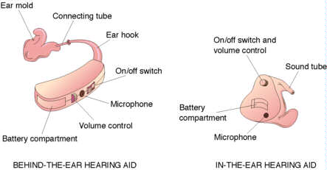

http://health.stateuniversity.com/pages/690/Hearing-Aids.html

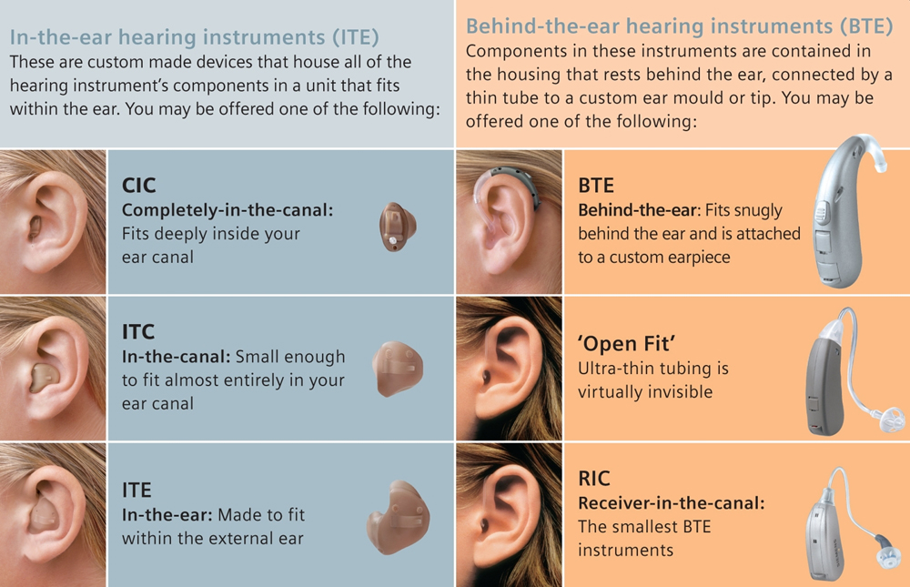
www.forestaudiology.co.uk

Hillside Elementary School Program on Disabilities – Hearing Loss
Kim Marie Nicols, MSW, MA

Conclusion (10 Minutes)

The students again gather into one large group, and the volunteer who did the Introduction and the Timekeeping will do the Conclusion.

The Wrap Up should include:
- Review of their experiences at each station
  - What the students learned
  - Things they had not known before and/or find interesting
- If time permits, a brief explanation of one or more:
  - “Causes of Hearing Loss”
  - “Communication Tips”
  - “Equipment and Services used by the Deaf or Hard of Hearing”
  - “Audiograms”
- Answer any questions
- Remind the students to show their parents the “Ask Me About…”.
- Teach the sign that Deaf people use for “applause”
(hands waving in the air instead of clapping)

Hillside Elementary School Program on Disabilities – Hearing Loss
Kim Marie Nicols, MSW, MA

2nd Grade Workshop
on
HEARING LOSS and DEAF & HARD OF HEARING PEOPLE

Today in your child’s 2nd grade classroom, a group of parent volunteers presented a workshop which introduced content related to Hearing Loss. To find out more about your child’s experience, you may want to:

ASK ME ABOUT …

- a word I learned in American Sign Language?

- how to fingerspell my name and count to 10 on my fingers?

- what it is like to understand words if you are Hard of Hearing?

- some words that look similar when lipreading?
(“I love you” looks the same as what?)

- how Deaf people made the sports of baseball and football better?

- what hearing aids look like?

- how I might communicate with someone who has a hearing loss?

- ways in which we have the same and different experiences as someone who is Deaf or Hard of Hearing?
Hillside Elementary School Program on Disabilities – Hearing Loss
Kim Marie Nicols, MSW, MA

Supplemental Materials

Audiogram
Audiogram Explanation
Sound Key

Communicating with a Hard of Hearing or Deaf Person

Communication Modes & Services & Equipment
Used by Deaf and Hard of Hearing People

Causes of Hearing Loss

Conserving Hearing

True Story Related by Kim Marie Nicols

AUDIOGRAM

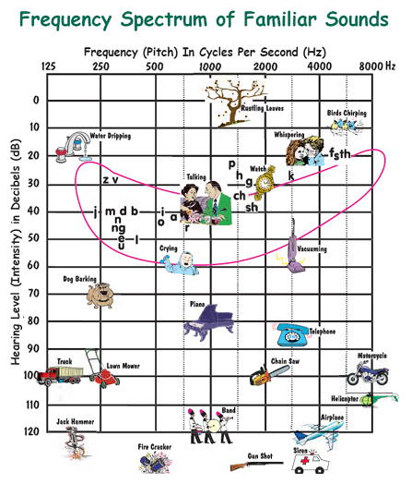
www.fetalhydrocephalus.com

Hillside Elementary School Program on Disabilities – Hearing Loss
Kim Marie Nicols, MSW, MA

AUDIOGRAM EXPLANATION

An Audiogram is a graph that shows the softest sounds a person can hear at different pitches (low and high sounds).

Frequency is measured in Hertz (HZ)

Low sounds are the lower numbers

High sounds are the higher numbers

Hearing Level is measured in Decibels (dB)

Soft sounds are the lower numbers

Loud sounds are the higher numbers
Exposure over 100 dB can cause a hearing loss

Normal Hearing (-10 – 25 dB)
Can hear all the letters in the English language and very soft to very loud sounds.

Mild Hearing Loss (25 – 40 dB)
Can hear most of the letters in the English language but will not hear many soft
environmental sounds. May decide not to get hearing aids.

Moderate Hearing Loss (40 – 70 dB)
Can hear most of the letters in the English language but will not hear soft
environmental sounds. Hearing aids can be helpful.

Severe Hearing Loss (70 – 90 dB)
Cannot hear conversations and many environmental sounds. Hearing aids can
help a little.

Profound Hearing Loss (over 90 dB)
Can only hear very loud environmental sounds. Hearing aids cannot help.

Hillside Elementary School Program on Disabilities – Hearing Loss
Kim Marie Nicols, MSW, MA

SOUND KEY on AUDIOGRAM OF FAMILIAR SOUNDS

Leaves Rustling -10 dB 1000 HZ
Birds Chirping 0 dB 8000 HZ
Faucet Dripping 10 dB 125 HZ
Whispering 10 dB 4000 HZ
Ticking Clock 25 dB 2000 HZ

Conversation 40 dB 1000 HZ

Vacuum 60 dB 2000 HZ
Baby Crying 60 dB 500 HZ
Dog Barking 70 dB 250 HZ

Piano 80 dB 1000 HZ
Telephone Ringing 90 dB 2000 HZ
Motorcycle 90 dB 8000 HZ

Lawn Mower 100 dB 250 HZ

Saw 100 dB 2000 HZ
Truck 110 dB 125 HZ
Helicopter 110 dB 8000 HZ

Jack Hammer 120 dB 125 HZ
Rock Band 120 dB 1000 HZ
Air Plane 120 dB 4000 HZ
Firecracker <120 dB 500 HZ
Gun Shot <120 dB 2000 HZ
Air Horn <120 dB 4000 HZ

The “Speech Banana” shows the Hearing Level and Frequency of average speech in the English language. A word like “moo” is easy to understand because it is fairly loud and a low sounding word, while “this” is harder to understand because it is a soft and high sounding word.
Hillside Elementary School Program on Disabilities – Hearing Loss
Kim Marie Nicols, MSW, MA

COMMUNICATING WITH A

HARD OF HEARING or DEAF PERSON

1. Get the person’s attention by waving your hand, tapping them lightly on the shoulder, or flashing the lights.

2. Reduce background noise, such as turning off the television, or go to a quieter area to talk.

3. Get closer to the person with a hearing loss and look straight at them. Do not try to converse from another room or if your back is turned.

4. Communicate in a place with good lighting so the person can see your facial expressions. Standing in front of a window puts your face in shadow.

5. Do not cover your face or look down, or talk with food or gum in your mouth.

6. Speak slower, lower, and a little louder, pronouncing your words clearly. Pause slightly around the important words. Do not yell, because that distorts your lips.

7. Let them know when there is a new topic of discussion.

8. Do not get mad or say “forget it” if the person asks you to repeat. Instead, try rephrasing what you want to say.

9. It is harder to hear and understand in group situations. People should take turns talking and try not to interrupt each other.

10. Use gestures, such as pointing or pantomiming, as you talk.

11. If you can fingerspell the manual alphabet or know any sign language, use it with a person whose primary language is American Sign Language. Do not be embarrassed that you may do a sign wrong. The important thing is to communicate!

12. Do not look at the interpreter if you are having a conversation with a Deaf or Hard of Hearing person who uses sign language. The interpreter’s job is to help out with the communication between you and the person with hearing loss, not to give their own opinions or teach you sign language. But after the conversation, it is polite to thank the interpreter for their assistance.
Hillside Elementary School Program on Disabilities – Hearing Loss
Kim Marie Nicols, MSW, MA

COMMUNICATION MODES & SERVICES & EQUIPMENT
USED BY DEAF AND HARD OF HEARING PEOPLE

COMMUNICATION MODES

Sign Language
American Sign Language (ASL) used in the USA and Canada
Every Country has its own Sign Language

Oral Communication
Lipreading
Speech
Hearing Some Sounds

Writing

Gestures and Pantomimes

SERVICES

Interpreters
Sign Language
Oral

Hearing Ear Assistance Dogs

Video or Telephone Relay Operators and Interpreters

EQUIPMENT

Telephone Devices
TTYs (Telecommunication Device for the Deaf)
Amplified Telephones
Video Telephones and Devices

Flashing Light and Vibrating Signal Devices
Telephone Ringing

Doorbell
Fire and Smoke Alarms
Alarm Clocks

Television
Closed Captioning
Amplified Sound

Listening Devices
Hearing Aids
Cochlear Implants
Personal Amplifiers
Hillside Elementary School Program on Disabilities – Hearing Loss
Kim Marie Nicols, MSW, MA

Causes of Hearing Loss

Temporary Hearing Loss
~ Ear Wax (Cerumen) Build-Up
~ Something Stuck in the Ear Canal
~ A Punctured Eardrum
~ A Cold or Allergies that Causes Excess Mucus
to Block the Eustachian Tube
~ Ear Infection (Otitis Media)
~ Medications and Drugs
~ Loud Noise
~ Ringing in the Ears (Tinnitus)

Permanent Hearing Loss
~ Heredity or Genetic Disorders
~ Prenatal Exposure to Disease
~ Diseases
~ Medications and Drugs
~ Loud Noise – Either Once or Long-Term Exposure
~ Trauma or Accident
~ Old Age (Presbycusis)
~ Unknown

Conserving Hearing

~ Get Away From or Use Ear Plugs Around Loud Noises
~ Turn Down the Volume of iPods, MP3 Devices, Etc.
that have Ear Phones or Ear Buds
~ Stay Healthy and Safe
~ The Only Thing You Should Put in Your Ear is
Your Elbow (try it)

Hillside Elementary School Program on Disabilities – Hearing Loss
Kim Marie Nicols, MSW, MA

Workshop on Hearing Loss

Presenting to a second grade class in January 2006, I had a funny experience…

As a wrap-up, I asked the students what they found interesting about Deaf and Hard of Hearing people. The answers included how difficult it was to understand words if you have a hearing loss (they listened to a tape simulating a loss), learning about the limitations of lipreading (‘elephant shoes’ and ‘I love you’ lipread the same), how much they enjoyed fingerspelling their names with the manual alphabet, and learning about the many contributions Deaf and Hard of Hearing people have made to our society (like improving the sports of baseball and football).

I asked one little boy what he would do if he met a Deaf person. “I would run away screaming,” was his reply. After gulping in shock, I discussed better ways to respond, and said that deafness should not be scary. “No,” he said, “they are like zombies and you do not want them touching you.” More stunned shock from me, other parent volunteers, and the teacher. Then I realized, he thought I said DEAD person!

The whole scenario reminded me of Gilda Radner from the old Saturday Night Live show. Her Hard of Hearing character of Emily LaTilla would eventually realize she had been confused by what she heard, and then say, “Oh, well that’s different. Never mind.”

Kim Marie Nicols, MSW, MA

Hillside Elementary School Program on Disabilities – Hearing Loss
Kim Marie Nicols, MSW, MA

Resources

Unfair Hearing Test

www.irrd.ca/education/hear/hear2_1.wav
download the ten words simulating a hearing loss
(the answers are fill, catch, thumb, heap, wise, wedge, fish, shows, bed, juice)
www.sightandhearing.org/products/knownoise.asp
$15 for the CD

American Sign Language Manual Alphabet and Vocabulary

Google Images – Manual Alphabet
variety of drawings and photos
www.asluniversity.com/asl101/fingerspelling/fingerspelling.htm
photos of the hand shapes with the letters on the wrists

http://aslbrowser.commtechlab.msu.edu/browser.htm
vocabulary words with descriptions and video

Ear Bones and Ear Model

www.universalmedicalinc.com
Auditory Ossicles Set (Ear Bones) - Product Code # DG212 - $36.86
Life-size Ear Model – Product Code #G225 - $52.37

Hearing Aids and Molds

Donations from Audiologists and Hearing Aid Dispensers

The hearing aids and molds used by Hillside Elementary School were donated by
Dr. Paul Milner, PhD, CCC-A
Hearing Care Center - Cobb’s Corner - 450 North Main Street - Sharon, MA 02067
(781-784-1944) - www.HearingCareCenter.com
Recommended Books (all available at Amazon.com)

Sesame Street Sign Language Fun with Linda Bove by Sesame Street
Sesame Street Sign Language ABC with Linda Bove by Sesame Street

The Handmade Counting Book by Laura Rankin
The Handmade Alphabet by Laura Rankin

Can You Hear a Rainbow?: The Story of a Deaf Boy Named Chris (Rehabilitation Institute of Chicago Learning Book) by Jamee Riggio Heelan Hardcover $12.44

Signs for Me: Basic Sign Vocabulary for Children, Parents & Teachers by Ben Bahan $10.17

Signing Is Fun (Perigee) by Mickey Flodin $8.00

Some Kids Are Deaf (Understanding Differences) by Lola M. Schaefer $5.36
This is a series that begin with Some Kids who: Are Blind / Use Wheelchairs /
Wear Leg Braces / Have Autism

Assistive Products and Sign Language Items

Harris Communications (800-825-6758) - www.harriscomm.com

Information and Resources

Massachusetts Commission for the Deaf and Hard of Hearing (617-740-1600) - www.mass.gov/mcdhh

National Association of the Deaf - http://www.nad.org

Hearing Loss Association of America - http://www.shhh.org/

